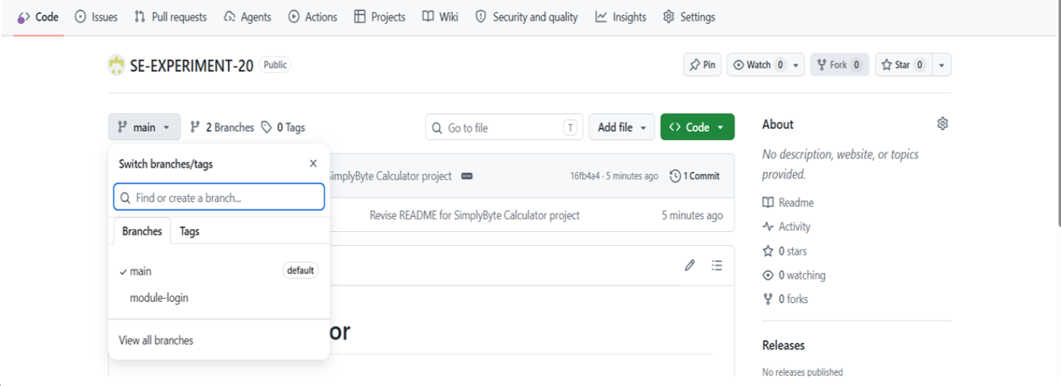

EXPERIMENT-21
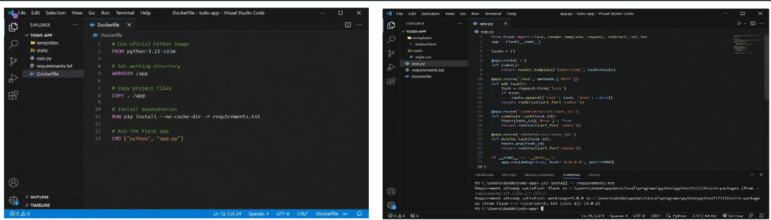

EXPERIMENT 22
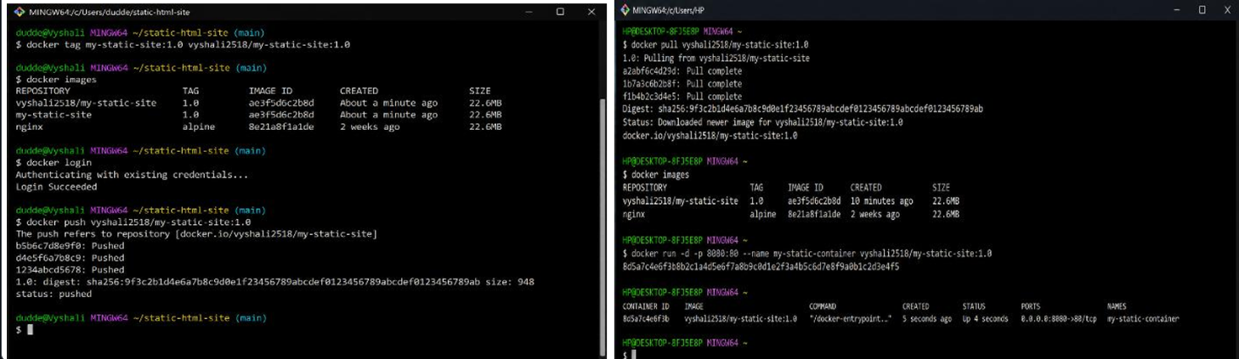

EXPERIMENT 23
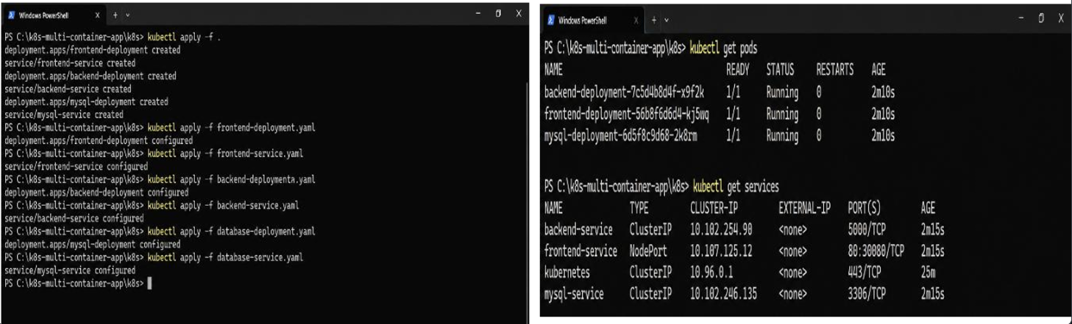

EXPERIMENT 24
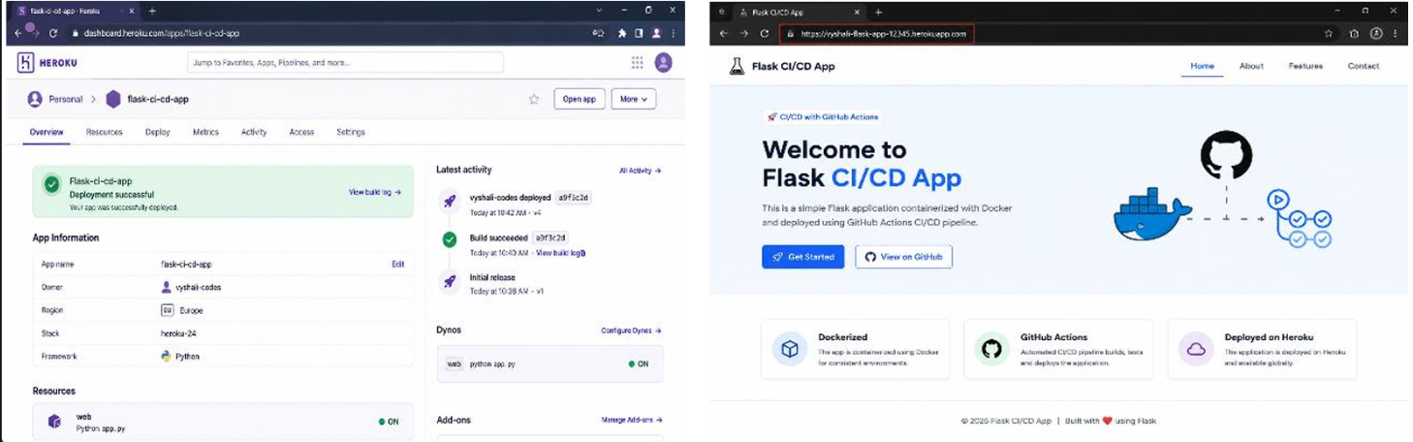
EXPERIMENT 26
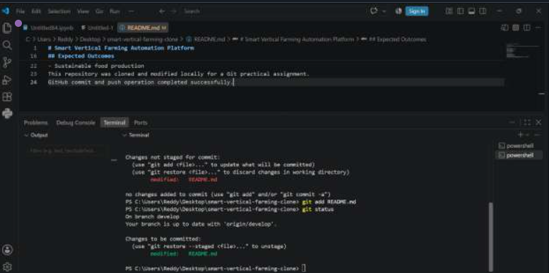

EXPERIMENT 27
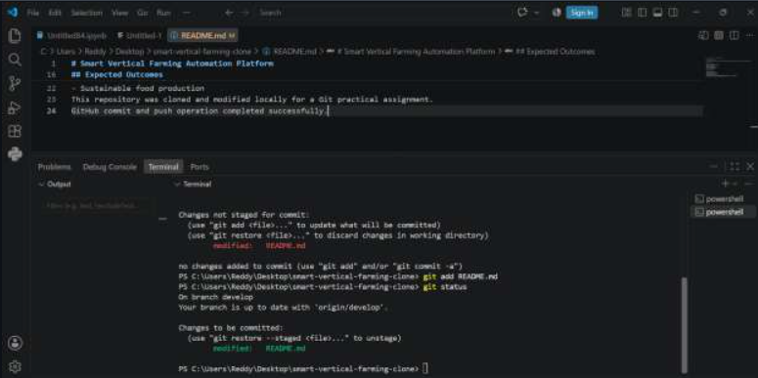

EXPERIMENT 28
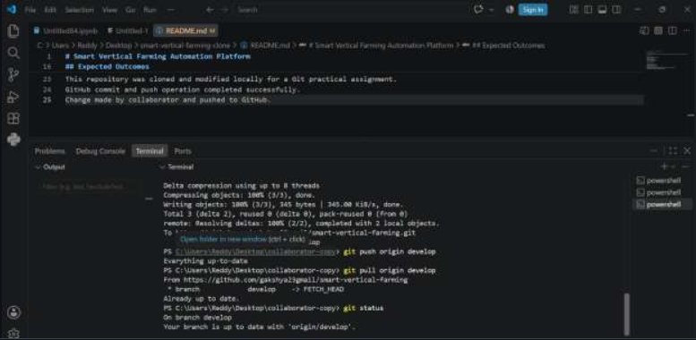

EXPERIMENT 29
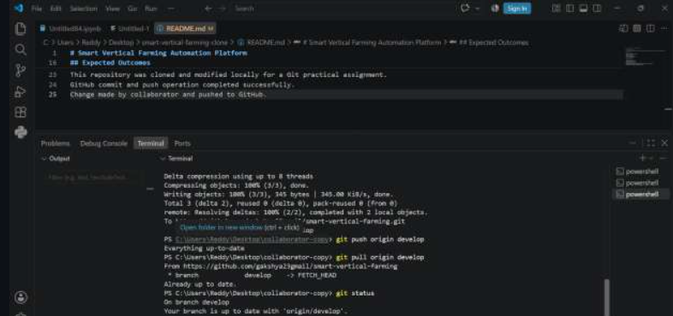
EXPERIMENT 30
